In this blog, we will learn about Apache Hive and Hive installation on Ubuntu.

**What is Apache Hive?**

**Apache Hive** is a data warehouse infrastructure that facilitates querying and managing large data sets which resides in distributed storage system. It is built on top of Hadoop and developed by Facebook. **Hive** provides a way to query the data using a SQL-like query language called **HiveQL(Hive query Language).**

Internally, a compiler translates **HiveQL** statements into **MapReduce** jobs, which are then submitted to **Hadoop framework** for execution.

**Difference between Hive and SQL:**

**Hive** looks very much similar like traditional database with **SQL** access. However, because **Hive** is based on **Hadoop** and **MapReduce** operations, there are several key differences:

As Hadoop is intended for long sequential scans and **Hive** is based on **Hadoop**, you would expect queries to have a very high latency. Itmeans that **Hive** would not be appropriate for those applications that need very fast response times, as you can expect with a traditional RDBMS database.

Finally, **Hive** is read-based and therefore not appropriate for transaction processing that typically involves a high percentage of write operations.

**Hive Installation on Ubuntu:**

Please follow the below steps to install **Apache Hive**on Ubuntu:

**Step 1:**  Download **Hive tar.**

**Command:** wget http://archive.apache.org/dist/hive/hive-2.1.0/apache-hive-2.1.0-bin.tar.gz

**Step 2:** Extract the **tar** file.

**Command:** tar -xzf apache-hive-2.1.0-bin.tar.gz

**Command:** ls

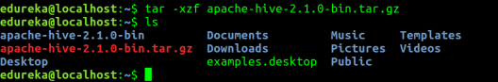

**Step 3: Edit the “.bashrc” file to update the environment variables for user.**

**Command:** sudo gedit .bashrc

Add the following at the end of the file:

***# Set HIVE_HOME***

***export HIVE_HOME=/home/edureka/apache-hive-2.1.0-bin***  
***export PATH=$PATH:/home/edureka/apache-hive-2.1.0-bin/bin***

Also, make sure that hadoop path is also set.

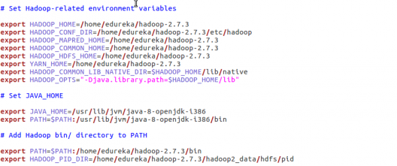

Run below command to make the changes work in same terminal.

**Command:** source .bashrc

**Step 4:** Check hive version.

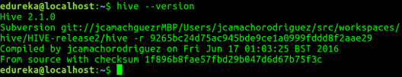

**Step 5:** Create **Hive** directories within **HDFS**. The directory **‘warehouse’** is the location to store the table or data related to hive.

**Command:**

* hdfs dfs -mkdir -p /user/hive/warehouse
* hdfs dfs -mkdir /tmp

**Step 6:** Set read/write permissions for table.

**Command:**

In this command, we are giving write permission to the group:

* hdfs dfs -chmod g+w /user/hive/warehouse
* hdfs dfs -chmod g+w /tmp

**Step 7:** Set **Hadoop** path in **hive-env.sh**

**Command:**cd apache-hive-2.1.0-bin/

**Command:** gedit conf/hive-env.sh

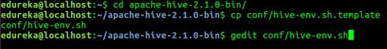

Set the parameters as shown in the below snapshot.

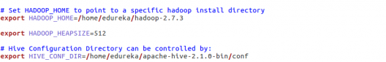

**Step 8:** Edit **hive-site.xml**

**Command:** gedit conf/hive-site.xml

<?xml version="1.0" encoding="UTF-8" standalone="no"?>

<?xml-stylesheet type="text/xsl" href="configuration.xsl"?><!--

Licensed to the Apache Software Foundation (ASF) under one or more

contributor license agreements. See the NOTICE file distributed with

this work for additional information regarding copyright ownership.

The ASF licenses this file to You under the Apache License, Version 2.0

(the "License"); you may not use this file except in compliance with

the License. You may obtain a copy of the License at

http://www.apache.org/licenses/LICENSE-2.0

Unless required by applicable law or agreed to in writing, software

distributed under the License is distributed on an "AS IS" BASIS,

WITHOUT WARRANTIES OR CONDITIONS OF ANY KIND, either express or implied.

See the License for the specific language governing permissions and

limitations under the License.

-->

<configuration>

<property>

<name>javax.jdo.option.ConnectionURL</name>

<value>jdbc:derby:;databaseName=/home/edureka/apache-hive-2.1.0-bin/metastore_db;create=true</value>

<description>

JDBC connect string for a JDBC metastore.

To use SSL to encrypt/authenticate the connection, provide database-specific SSL flag in the connection URL.

For example, jdbc:postgresql://myhost/db?ssl=true for postgres database.

</description>

</property>

<property>

<name>hive.metastore.warehouse.dir</name>

<value>/user/hive/warehouse</value>

<description>location of default database for the warehouse</description>

</property>

<property>

<name>hive.metastore.uris</name>

<value/>

<description>Thrift URI for the remote metastore. Used by metastore client to connect to remote metastore.</description>

</property>

<property>

<name>javax.jdo.option.ConnectionDriverName</name>

<value>org.apache.derby.jdbc.EmbeddedDriver</value>

<description>Driver class name for a JDBC metastore</description>

</property>

<property>

<name>javax.jdo.PersistenceManagerFactoryClass</name>

<value>org.datanucleus.api.jdo.JDOPersistenceManagerFactory</value>

<description>class implementing the jdo persistence</description>

</property>

</configuration>

**Step 9:** By default, Hive uses **Derby** database. Initialize Derby database.

**Command:**bin/schematool -initSchema -dbType derby

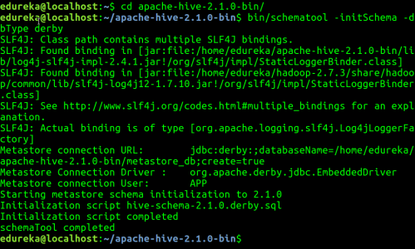

**Step 10**: Launch **Hive.**

**Command:** hive

**[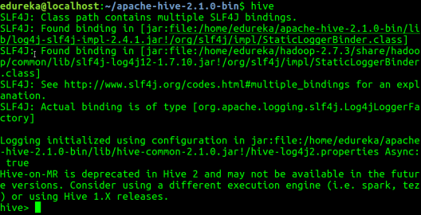](http://www.edureka.co/blog/apache-hive-installation-on-ubuntu/)**

**Step 11**: Run few queries in Hive shell.

**Command:** show databases;

**Command:** create table employee (id string, name string, dept string) row format delimited fields terminated by ‘\t’ stored as textfile;

**Command:** show tables;

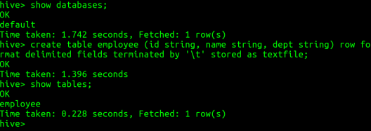

**Step 12:** To exit from **Hive:**

**Command:** exit;

Now that you are done with Hive installation, the next step forward is to try out Hive commands on Hive shell. Hence, our next blog “[***Top Hive Commands with Examples in HQL***](https://goo.gl/LMwZHv)” will help you to master Hive commands.